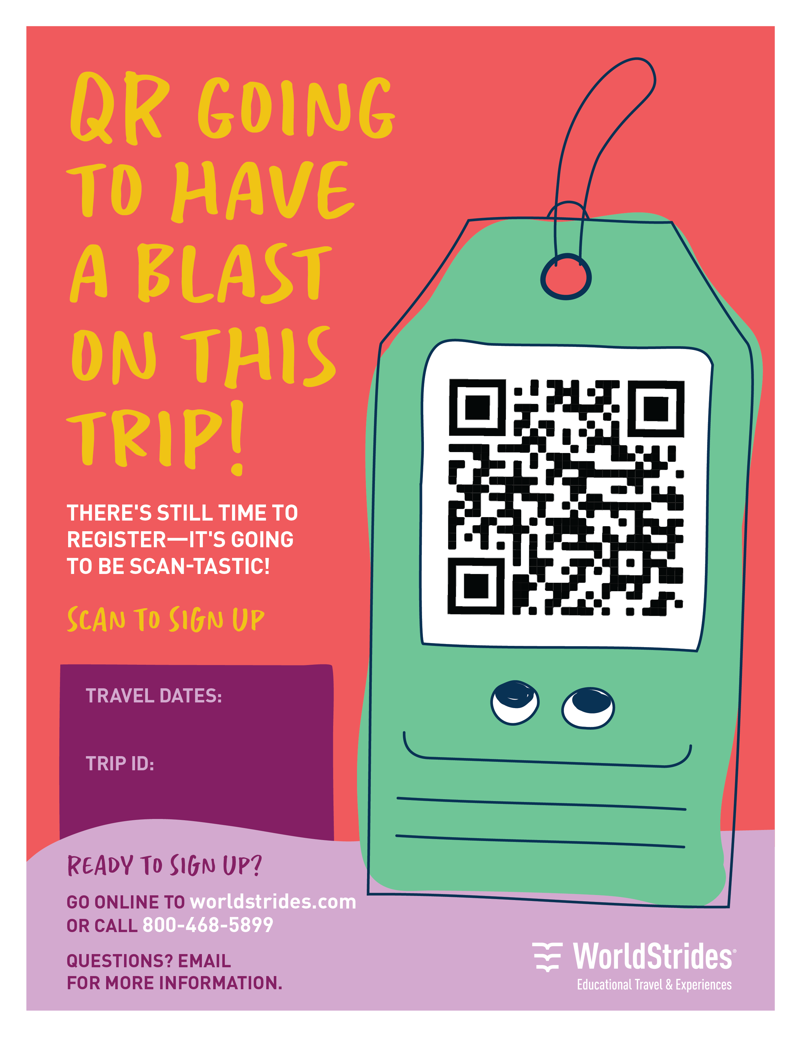

**<<insert email address>>**

**<<insert travel dates>>**

**<<insert trip ID>>**